Introducing the friendly team of

Flagstaff Medical Centre

* MB ChB (Otago) DA (London) FRNZGP
* PG Cert Health Sciences (A&D) FAChAM
* Family Physician
* Fellow of the Royal NZ College of General Practitioners
* Fellow of Royal Australian College
* Addiction Medicine Practitioner
* MB ChB (Otago) DCH (Otago)

FRNZGP

* General Practitioner
* Fellow of the Royal College of

General Practitioners

* Special interests in Paediatrics

and Women’s Health







**Dr Ken Couper**

Director

**Dr Marilyn**

**Griffiths**

Director

**Lenare Martin**

Practice Manager

* MB ChB (UK) FRNZGP
* Family Physician
* Fellow of the Royal College of

General Practitioners

* MB ChB (Auckland) Dip Paeds FRNZCGP
* General Practitioner
* Fellow of the Royal College of General Practitioners
* Special interests in Paediatrics and Women’s Health

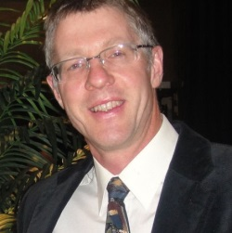

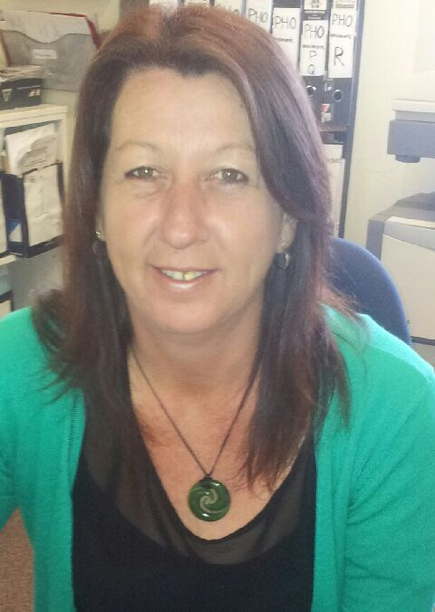



**Dr Nigel Eaves**

**Dr Tammy**

**Wong**

**Glenda Edwards**

Medical Receptionist





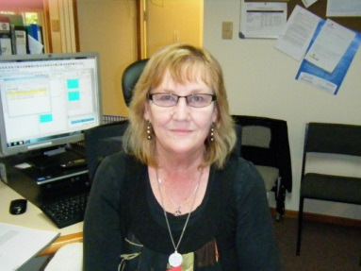

**Leanne Ryan**

Practice Nurse

**Helen Shaw**

Practice Nurse

**Heather Robertson**

Administrative Nurse

**Useful Telephone Numbers**

**Ambulance/Fire/Police 111**

**Flagstaff pharmacy 07 854 0445**

**Lifeline 24 Hour Counselling Line 07 838 0719**

**Alcoholics Anonymous 0800 229 6757**

**(24hr Health Line) 0800 611 116**

**(Including Plunket Line)**

**Citizens Advice Bureau (55 Victoria St) 07 839 0395**

**National Poisons Centre**

**Urgent 0800 764 766**

**Non urgent 03 479 7248**

**Waikato Hospital 07 839 8899**

Consultation Time: 15 minutes (extra charges incurred if consultation is longer; please advise prior if longer is required)

Casual patients are required to pay prior to consultation

***$5.00 will be added to accounts not paid on the day***

**Flagstaff Medical Centre**

Our commitment to you

* We undertake to provide all patients with the best possible medical service and we will conduct our day to day activities with the utmost integrity and respect
* We pride ourselves on providing a professional, confidential and individual medical centre
* At Flagstaff Medical Centre you will always find a cheerful, caring atmosphere where all are treated with respect and integrity

__________________________

**Emergencies**

Visits to the surgery without an appointment are welcome in emergency situations

***After Hours:*** *Please call Anglesea Medical Centre on 07 858 0800*

**Please advise if you require urgent attention**

**Repeat Prescriptions**

*Prescriptions require 24 hours’ notice*

If your condition is stable and you have seen the doctor recently we can provide a prescription.

**Diagnostic Lab**

A Pathlab Nurse is available Monday to Friday from 8:00am to 5:00pm

**Flagstaff Medical Centre**

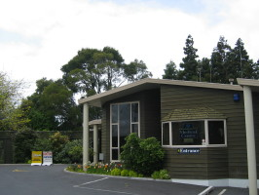

**Personalised, Friendly Care** **Relaxing Environment** **Same Day Appointments**

**2 Endeavour Avenue**

**Flagstaff, Hamilton**

**Ph.: 07 854 0189**

**Fax: 07 854 0738**

**Surgery Hours**

**8:00am to 5:00pm**

**Monday to Friday**

**________________________**

**After Hours Contact:**

**Anglesea Clinic**

**Corner Anglesea & Thackeray Streets**

**07 858 0800**

